Log Analysis Report
Introduction
In this 21st century, forensic log analysis has become one of the most important security tools today in threat identification and analysis. Regular production of forensic reports by security experts is an important practice that every industry today needs to adopt. In our scenario, we are to produce a log report based on the connectivity details of the server.
What are the high-level trends in connectivity to/from the server? What type of traffic was growing/ decreasing?
The following ports have been arranged in descending order indicating where the activity was more;
Destination Port | Packets | Port
135 | 88157 | DCE Endpoint resolution
445 | 46439 | Win 2K Server Message Block
443 | 26444 | SSL
3127 | 25781 | W32.MyDoom
53 | 18156 | DNS
139 | 15000 | NetBIOS Session
80 | 13310 | WWW
137 | 8752 | NetBIOS Name Service
1434 | 5909 | Microsoft SQL server
138 | 3819 | NetBIOS Datagram
The IP addresses below indicate the servers that received the highest activity/ traffic.
IP ADDRESS | NUMBER OF PACKETS
11.11.11.75 | 30130
11.11.11.80 | 13255
11.11.11.67 | 12381
11.11.11.100 | 11417
11.11.11.90 | 11359
11.11.11.71 | 11062
11.11.11.87 | 10994
11.11.11.105 | 10915
11.11.11.115 | 10842
11.11.11.110 | 10839
The following IP addresses sent the highest traffic to the honey port servers;
IP ADDRESS | NUMBER OF PACKETS
11.11.11.67 | 22815
66.60.166.84 | 21829
66.186.83.178 | 10197
63.13.135.27 | 8121
127.0.0.1 | 6394
63.123.70.166 | 4018
63.125.10.7 | 3794
63.126.133.117 | 2801
67.123.234.132 | 2334
63.126.133.8 | 2087
The following screenshots indicate changes in activity in some of the ports;
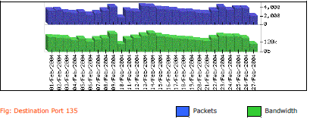
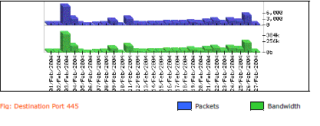
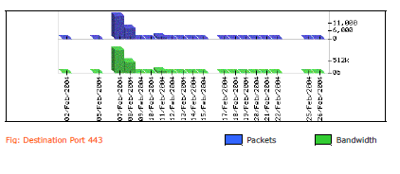
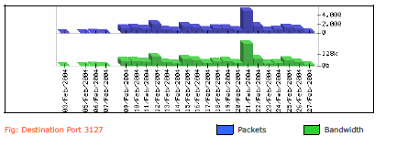
What possible evidence of malware is there? What types? What are the malware trends you can observe?
The Mydoom and MS Blaster worm are evident in the fact that TCP port 3128 has been seen to involve a lot of activity. Mydoom virus is evident when an IP address (11.11.11.73) listens on port 3128. The types of malware in the network are W32/Blaster and MyDoom. Microsoft RPC DCOM vulnerability was exploited by the malware via port 135.
The infection by Mydoom virus can be shown in below screenshot where the IP address 11.11.11.73 is found to listen on port 3128.
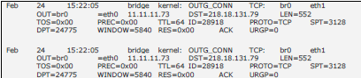
The below images show the malware trends in the network.
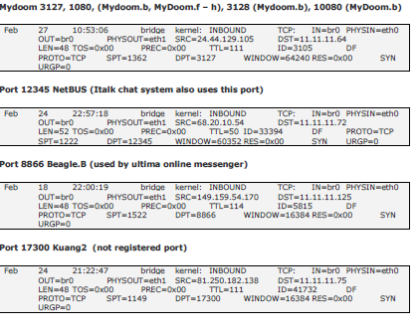
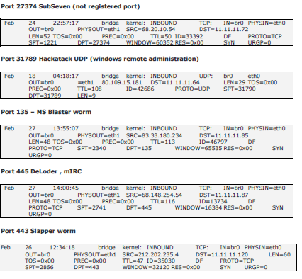

What types of reconnaissance activity did you notice? What do you think attackers were looking for? What are some prominent sources of such activity in the files?
The below activities were identified during the reconnaissance;
The IP address 63.125.10.7 was involved in a ping sweep activity.
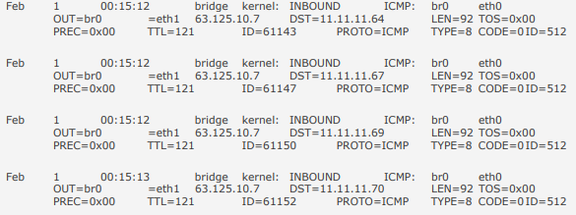
An attempt on DNS zone transfer was also evident.
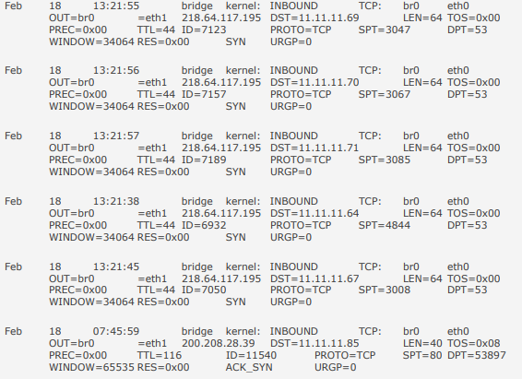
A probe was conducted on port 135 by echo requests from ICMP (63.123.70.166).
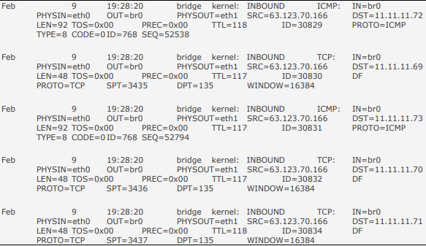

The attackers aimed at identifying the following details; Getting to know the list of open ports, to know the active network machines and to conduct DNS zone transfer attempts. The extracts of such online activity have been indicated below;
63.123.70.166
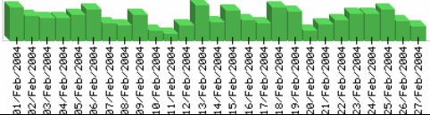
63.125.10.7
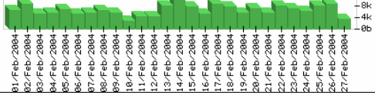
218.64.117.195
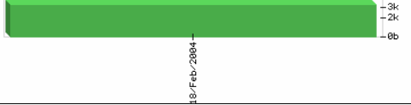

What are the different scan patterns that you can notice? Do you think all come from different attack tools? Address/note any long term ("low and slow") scanning activity.
The highest number of scans was targeted at specific ports including 137, 139, 443 and 445. ICMP sweep scans (sequential) were noticed from 63.123.70.166. Open proxy ports (80, 8080 and 3128) were associated with another scan. Backdoor ports were left open due to the high level scan done on them. ICMP echo request and TCP probe were also evident. Different attack tools were used in the attack as the scan variations and patterns are evident. The image below indicates a long term slow scanning activity on ICMP and TCP/ SYN packets.

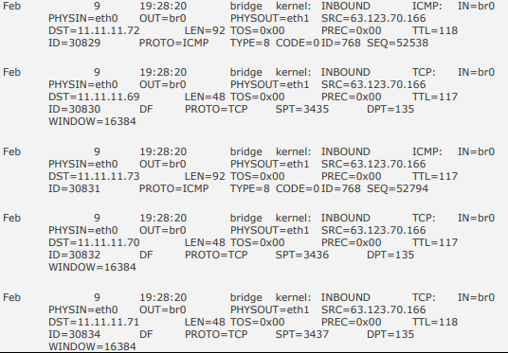

Was the network compromised during the observed time period? How do you know?
Yes. The following machines may have been compromised during the attack; 11.11.11.73, 11.11.11.67, 11.11.11.75, 11.11.11.80, 11.11.11.71. After a number of connections, the honeypot should drop packets from the internal IP address to external but in the logs, some machines seem to have dropped after the 13 limit placed in the honeypot. The screenshot shows that further attempts were done after 13th limit.
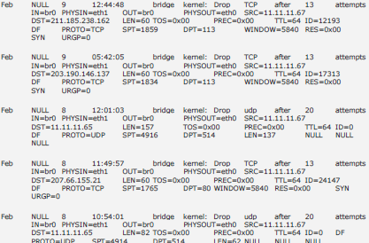

If you'd obtain such firewall logs from a production system, what source IPs or groups of such IPs would you focus on as a highest threat?
Source IP Address | Reason
66.60.166.84 | In the log file, SYN attack is evident on port 443 (11.11.11.75)
66.186.83.178 | This IP address aimed at exploiting Microsoft RPC DCOM vulnerability on port 139 and 445.
63.13.135.27 | It targeted on port 139 and 445.
What systems were attacked the most? What ports were open on each of them? Why do you think machines with close IP addresses were attacked differently?
IP ADDRESSES | PACKETS RECEIVED | OPEN PORTS
11.11.11.75 | 30130 | 443, 80
11.11.11.80 | 13255 | 443, 80
11.11.11.67 | 12381 | 443

Different attack methods on different machines were used to reduce the chances of detection by the system. Moreover, the individual machines may be having different systems that need different attack tools.
Provide some high-level metrics about the data (such as most frequently targeted ports, etc) and make some conclusions based on them.
Port | Protocol | Number of packets | Explanation
135 | TCP | 88157 | DCE resolution
445 | TCP | 46439 | SMB
443 | TCP | 26444 | SSL
3127 | TCP | 25781 | MyDoom
139 | TCP | 15000 | File and Printer Sharing
1434 | TCP | 5909 | SQL server (Microsoft)
Basing on the data indicated on the table above, we can draw some conclusions that there was high activity on the MyDoom backdoor and on port 135, 445 and 139. SYN attack was also identified in the scan as shown below;
